**Topics: Descriptive Statistics and Probability**

1. Look at the data given below. Plot the data, find the outliers and find out $μ, σ, σ^{2}$

|  |  |
| --- | --- |
| **Name of company** | **Measure X** |
| Allied Signal | 24.23% |
| Bankers Trust | 25.53% |
| General Mills | 25.41% |
| ITT Industries | 24.14% |
| J.P.Morgan & Co. | 29.62% |
| Lehman Brothers | 28.25% |
| Marriott | 25.81% |
| MCI | 24.39% |
| Merrill Lynch | 40.26% |
| Microsoft | 32.95% |
| Morgan Stanley | 91.36% |
| Sun Microsystems | 25.99% |
| Travelers | 39.42% |
| US Airways | 26.71% |
| Warner-Lambert | 35.00% |

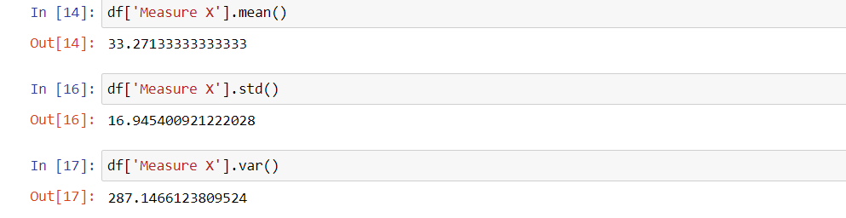

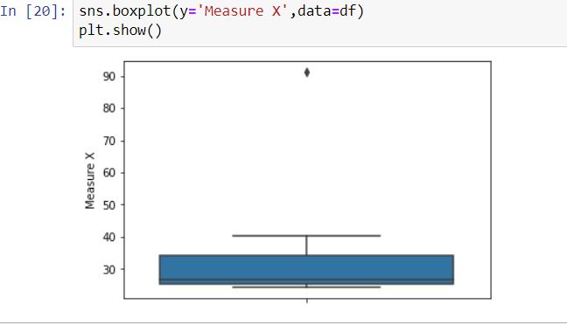



Answer the following three questions based on the box-plot above.

1. What is inter-quartile range of this dataset? (please approximate the numbers) In one line, explain what this value implies.

ANS­­🡪**IQR=Q3-Q1=12-5=7**

1. What can we say about the skewness of this dataset?

ANS🡪**Right Skewed**

1. If it was found that the data point with the value 25 is actually 2.5, how would the new box-plot be affected?

ANS🡪**It won’t be affected much and no outliers will be there**



Answer the following three questions based on the histogram above.

1. Where would the mode of this dataset lie?

**ANS🡪Mode will lie between 5 and 8**

1. Comment on the skewness of the dataset.

**ANS🡪.Right skewed dataset**

1. Suppose that the above histogram and the box-plot in question 2 are plotted for the same dataset. Explain how these graphs complement each other in providing information about any dataset.

**ANS**🡪 **Both Plots give idea about skewness of the data but,**

**using histogram, we can find frequency distribution of data but we cannot detect**

**outliers by using boxplot we can find outlier value.**

1. AT&T was running commercials in 1990 aimed at luring back customers who had switched to one of the other long-distance phone service providers. One such commercial shows a businessman trying to reach Phoenix and mistakenly getting Fiji, where a half-naked native on a beach responds incomprehensibly in Polynesian. When asked about this advertisement, AT&T admitted that the portrayed incident did not actually take place but added that this was an enactment of something that “could happen.” Suppose that one in 200 long-distance telephone calls is misdirected. What is the probability that at least one in five attempted telephone calls reaches the wrong number? (Assume independence of attempts.)

**P(calls misdirected)= 1/200**

**P(calls not misdirecting)=1- P(call is misdirected)=199/200**

**Number of calls=5 ,**

**Probability that at least one in 5 attempted call reaches the wrong number**

**= 1 - no call reaches the wrong number**

**= 1 – (199/200)×(199/200) × (199/200) × (199/200) × (199/200)**

**= 1 - ${(199/200)}^{5}$**

**= 0.025**

1. Returns on a certain business venture, to the nearest $1,000, are known to follow the following probability distribution

|  |  |
| --- | --- |
| x | P(x) |
| -2,000 | 0.1 |
| -1,000 | 0.1 |
| 0 | 0.2 |
| 1000 | 0.2 |
| 2000 | 0.3 |
| 3000 | 0.1 |

1. What is the most likely monetary outcome of the business venture?

**ANS🡪 When x=2000 the probability is more.Therefore the most likely monetary outcome of the business venture is 2000**

1. Is the venture likely to be successful? Explain

**ANS🡪Yes ,the venture is likely to be successful. As there is a 80 % chance of making profit whereas the loss is only 20%**

1. What is the long-term average earning of business ventures of this kind? Explain

**ANS🡪Long term average earnings = (-2000×0.1)+ (-1000×0.1)+ (1000×0.2)+ (2000×0.3)+ (3000×0.1) =$800**

1. What is the good measure of the risk involved in a venture of this kind? Compute this measure

**ANS**🡪Var (X) = E(X²) – (E(X))²

  =2800000 -   800²

=**2160000**

SD =  **$ 1470(apprx)**

Variance is high therefore the risk involved is high